7.1.5 Editors - 3D View - Tool Shelf - Mesh - Weight Paint Mode
Tool Shelf - Mesh - Weight Paint Mode 2
Transform and Annotate tools 2
Brush cursor 2
Brushes settings 2
Symmetry 3
Hotkeys 3
Draw 3
Add 3
Darken 4
Draw 4
Lighten 4
Mix 4
Multiply 4
Subtract 4
Blur 4
Average 4
Smear 4
Gradient 4
Tool Settings 5
Weight 5
Strength 5
Type 5
Last Operator Weight Gradient 5
Type 5
Sample tools group 5
Sample Weight 5
Sample Vertex Group 5

Tool Shelf - Mesh - Weight Paint Mode
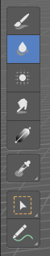
In Vertex Paint mode with a mesh object you will find mainly brushes in the tool shelf. Vertex painting allows you to paint the vertices of a mesh object with a specific color. This can then be used in various ways. As direct painting without any UV mapping. Or for some special calculations. There is a shader node that reads the vertex color values.

Transform and Annotate tools

The transform and annotate tools at the end of the list are explained in the chapter 7.1.1 Editors - 3D View - Tool Shelf - Object Mode. We won't cover this tools again here.
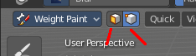
The transform tools group shows when you activate Paint Mask or Vertex selection sub modes.

Brush cursor
When you activate one of the brushes then the mouse cursor turns into a brush cursor. This cursor represents the size of the current brush. It does not align with the surface under the mouse. But always faces towards you.
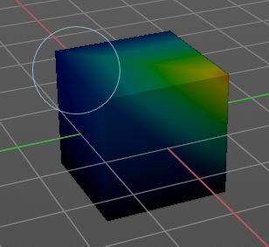

Brushes settings

The different brushes settings can be found in the sidebar in the tools tab. Or in the properties editor in the Active Tool and Workspace settings tab. Or above the header area.

The different brushes settings in the Active Tool and Workspace settings are explained in the chapter 25.1.4 Editors - Properties Editor - Tools Tab - Vertex Paint Mode

We won't cover this chapters again, but just explain what the different brushes does.

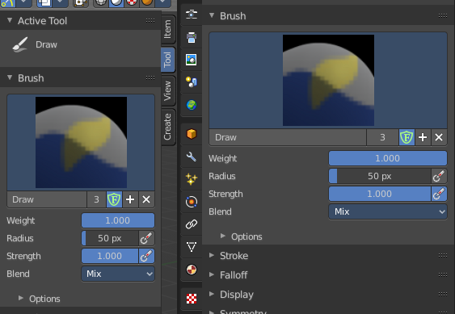
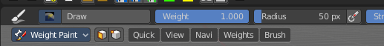

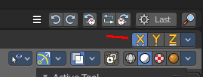
Symmetry
You can enable Symmetry painting up right in the header.

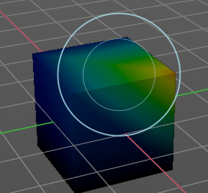
Hotkeys
Pressing F allows you to change the brush size onscreen. Drag the mouse to increase or decrease the size. Left click applies the new size, right click cancels the resizing.

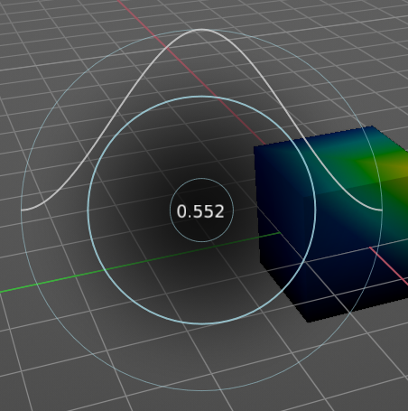
Pressing Shift F allows you to change the strength of the brush. Drag the mouse to increase or decrease the size. Left click applies the new size, right click cancels the resizing.

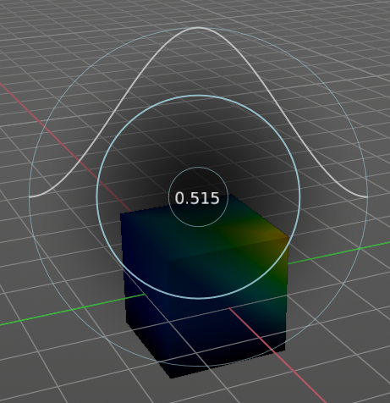
Pressing Ctrl F allows you to change the weight size onscreen. Drag the mouse to increase or decrease the size. Left click applies the new size, right click cancels the resizing.

Draw
Draws a stroke. The Draw tool has several sub brushes in the Brush panel. The names of the brushes are pretty self explaining.
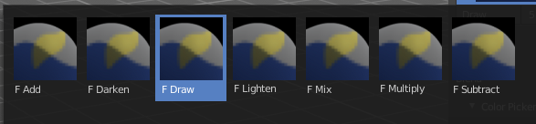

Add
The specified weight value is added to the vertex weights. The strength determines which fraction of the weight gets added per stroke. But the brush will not paint weight values above 1.0.

Darken
Darkens the current color at the vertices down to the specified target value. Only weights above the target weight are affected. Weights below the target weight remain unchanged.

Draw
Draws a stroke.

Lighten
Lightens the current color at the vertices up to the specified target value. Only weights below the target weight are affected. Weights above the target weight remain unchanged.

Mix
Mix the color that you draw with the background color.

Multiply
Multiplies the color that you draw with the background color.

Subtract
Removes the color from the vertex with drawing.

Blur
Smooths out the colors of adjacent vertices. In this mode the Color Value is ignored. The strength defines how much the colors are blurred.

Average
Smooths color by painting the average resulting color from all colors under the brush.

Smear
Smudges colors by grabbing the colors under the brush and “dragging” them.

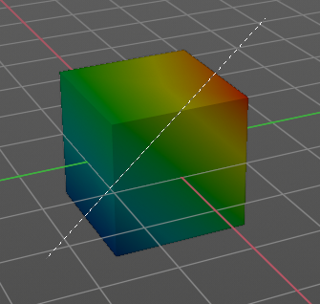
Gradient
Allows you to draw a gradient between two defined points. The gradient gets drawn with the starting color at the start point, and the color for zero weight at the end point.

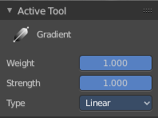
Tool Settings

Weight
The starting weight.

Strength
The strength with which it mixes with the existing weighting.

Type
Here you can choose the gradient type. Linear or Radial.

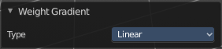
Last Operator Weight Gradient

Type
Here you can choose the gradient type. Linear or Radial.

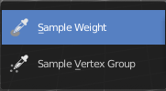
Sample tools group

Sample Weight
Sets the actual weight value to the color under the mouse.

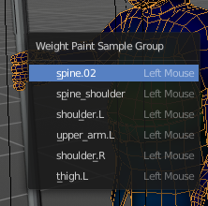
Sample Vertex Group
Opens a popup menu where you can select one of the vertex groups that are under the mouse.

